Name: Akash Arjun Sawant
Student ID: AF05009971
Batch code: ANP-D1396

Day 1 Lab
Assignment 1. Create a simple Webpage using basic HTML elements to understand the structure of an HTML document.

Code:
<!DOCTYPE html>
<html lang="en">
<head>
<title>My First Webpage</title>
</head>
<body>
<h1>Welcome to My Webpage</h1>
<a href="https://www.anudip.org" target="_blank">Visit Anudip Page</a>
</body>
</html>

Output:
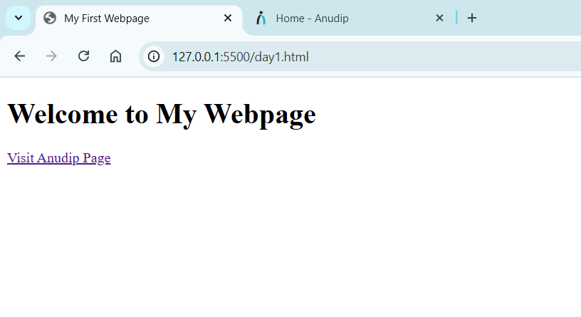
Assignment 2. Create a simple Webpage using an online HTML editor.

Code:
<!DOCTYPE html>
<html lang="en">
<head>
<title>Welcome to my Web Page</title>
</head>
<body>
<h1>Akash Sawant</h1>
<p>Hi, I am Akash Sawant. I have completed my education in Computer Science and currently work as a software developer. I have technical expertise in web development, including HTML, CSS, JavaScript, and other modern technologies.</p>
</body>
</html>

Output:
